Creating an Inbound Delivery Final

Open RT3

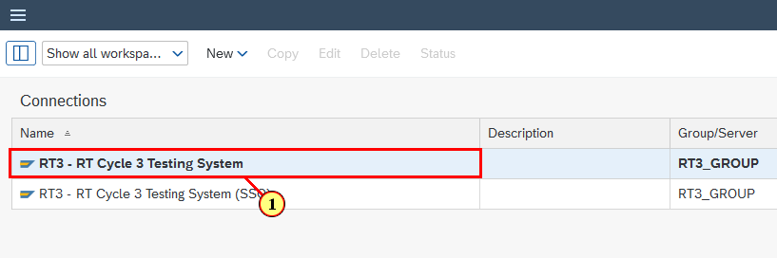

(1) **RT3** system is selected.

Input T-Code for Inbound Delivery Creation

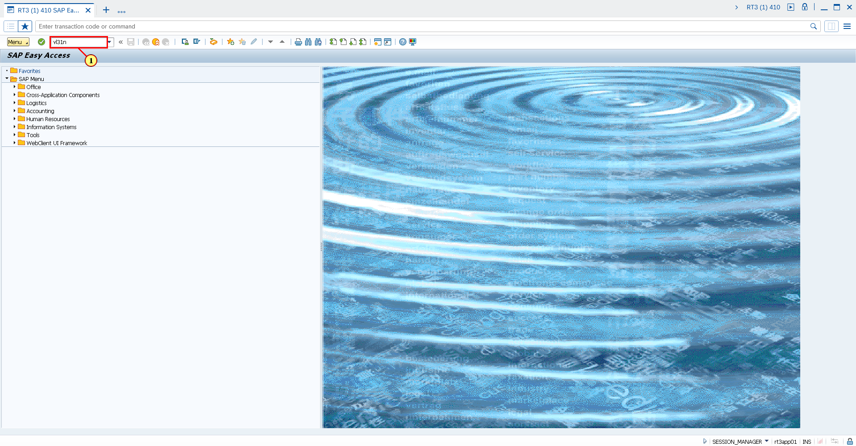

(1) **vl31n** is now entered in the **Transaction box**.

Fill out Supplier field

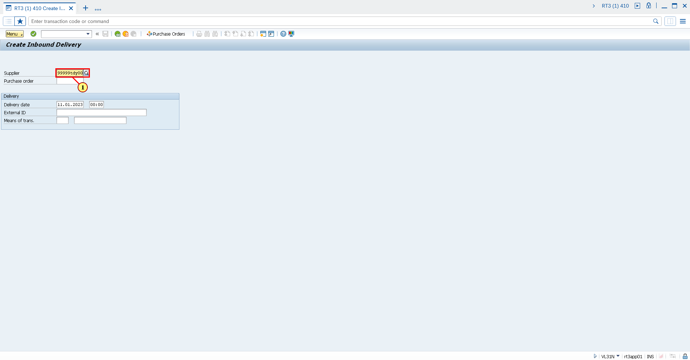

(1) The **Supplier** field is filled out.

Fill out Purchase Order field

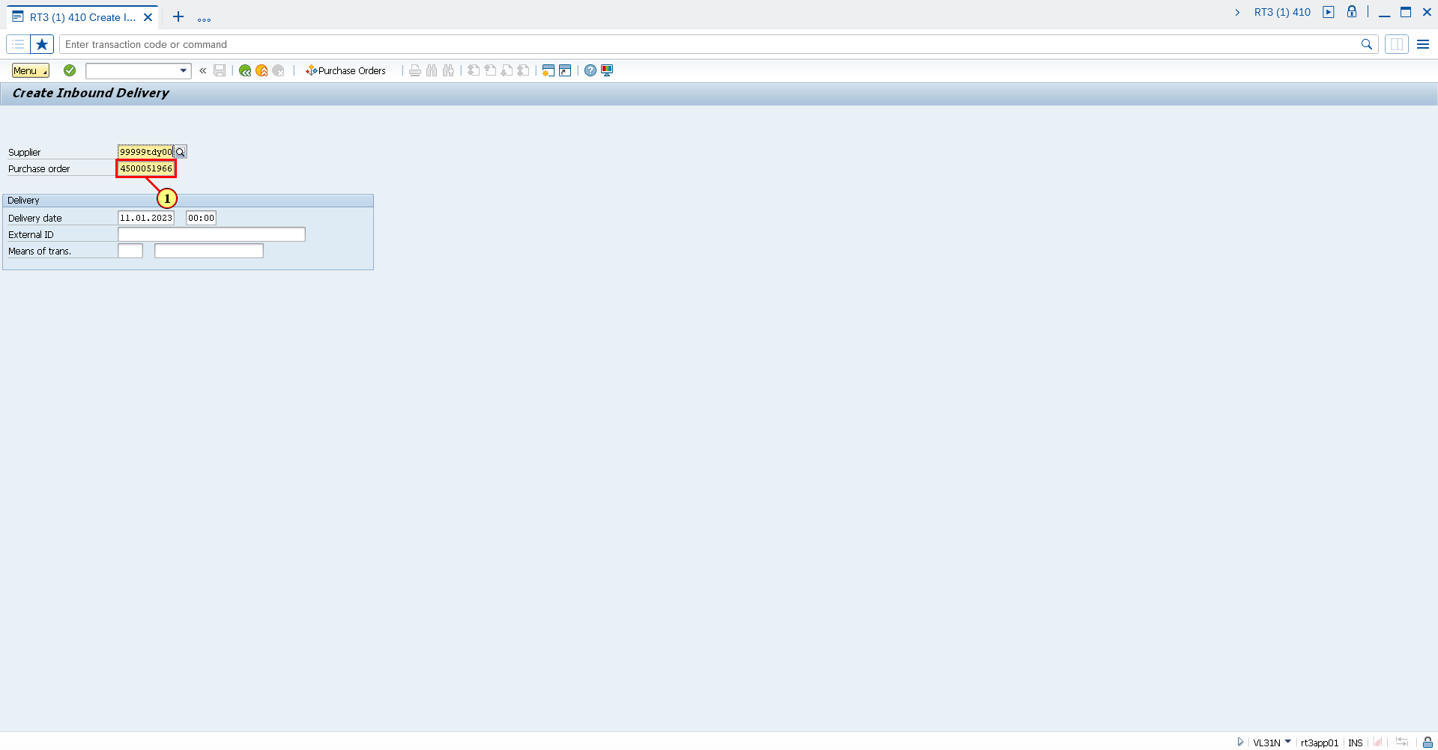

(1) The **Purchase order** field is filled out.

Fill out External ID field

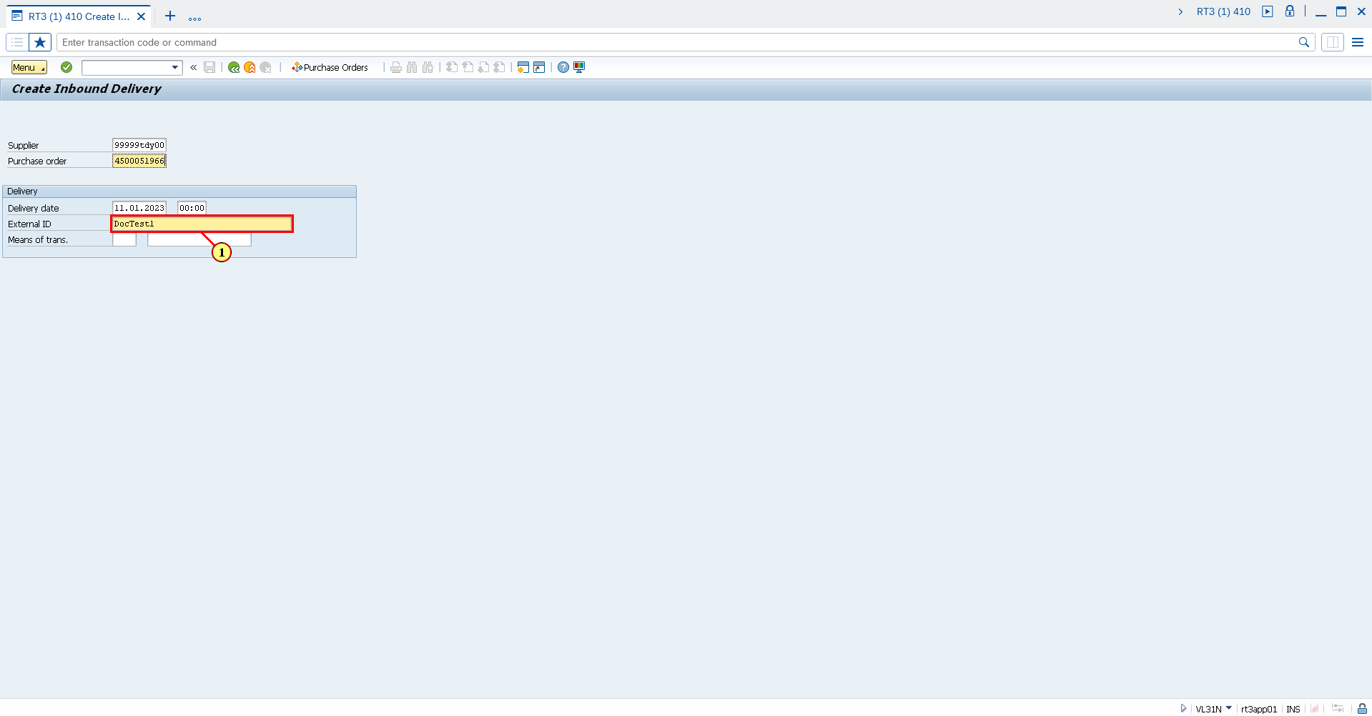

(1) The **External ID** field is filled out.

Save Inbound Delivery

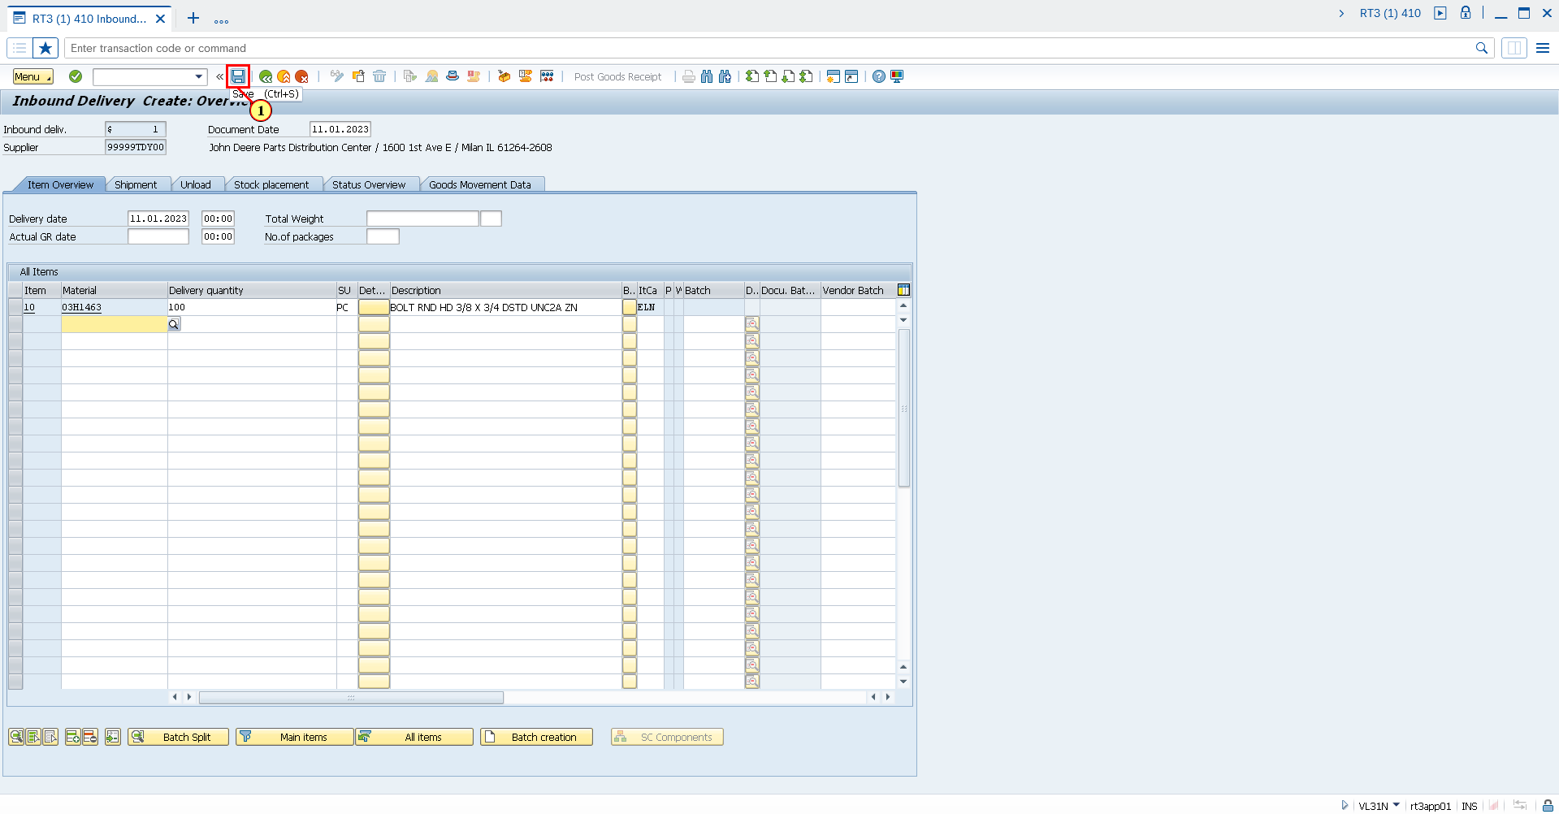

(1) Click **Save**.

You can also press **Ctrl+S**.

Confirm creation of Inbound Delivery

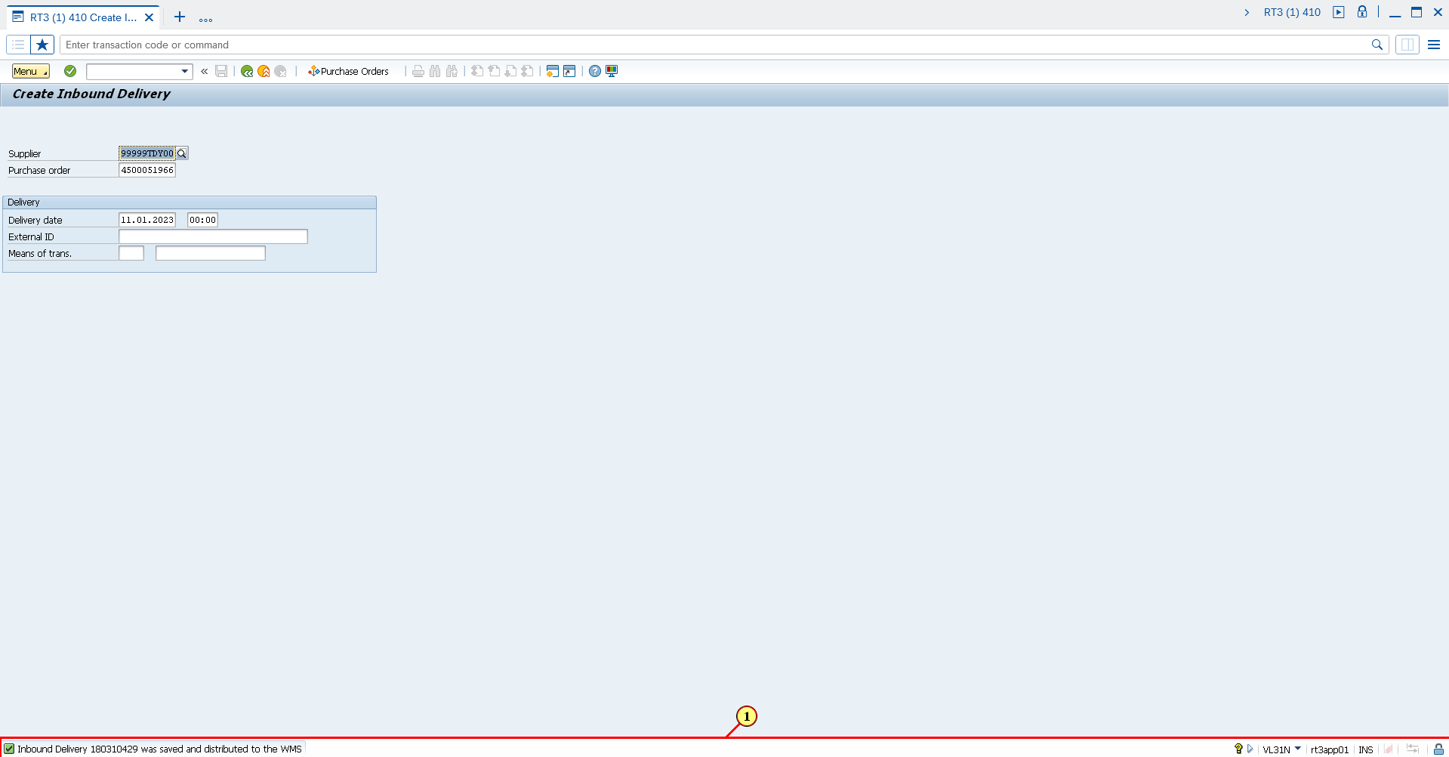

(1) Confirms successful creation of Inbound Delivery